Setup Environment
Install the following developer tools
Use these tools while creating code apps:
- Your IDE of choice. For example, Visual Studio Code
- Node.js (LTS version) – 22+ https://nodejs.org/en/download
- Git - https://git-scm.com/install/windows
- Power Apps CLI - https://marketplace.visualstudio.com/items?itemName=microsoft-IsvExpTools.powerplatform-vscode

Create New Environment – follow document Create and manage an environment.docx

Enable code apps on a Power Platform environment
Admins can enable code apps by setting an environment option. Power Platform admins and environment admins can set this option. The environment setting respects groups and rules set by Power Platform admins.
- As an admin, go to Power Platform admin center.
- Go to Manage > Environments > select the environment where you use code apps.
- Go to Settings > Expand the Product subsection > Select Features.
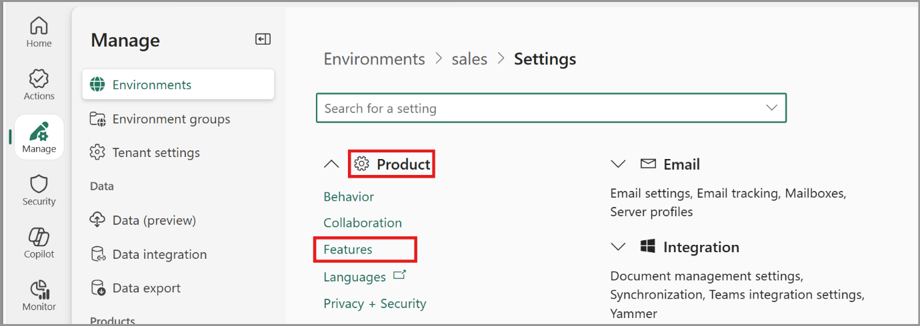

- Go to the feature Power Apps code apps and use the Enable code apps toggle to turn it on.
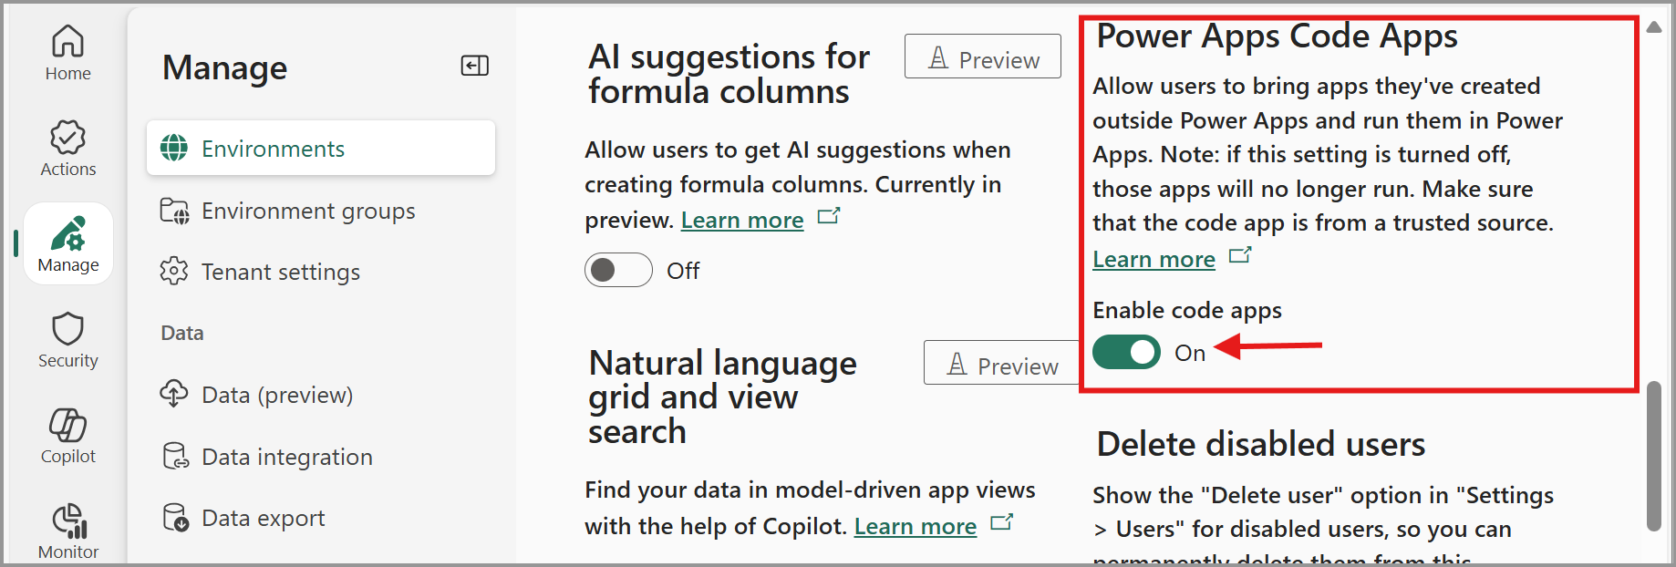
- Select Save in the settings experience.

License end users with Power Apps Premium
End users that run code apps need one of the following:
- Power Apps Premium license
- Pay-as-you-go enabled
- An App Pass
- Auto-claim enabled. This option automatically assigns a premium license to the user if one is available in the tenant.

